**Report:**

**Food panda:**

* **Get auto location**

As a user I want get auto location feature so that I can be able to click on the pin and my pin will get may location.

**Acceptance criteria:**  
the acceptance criteria for this feature could be that the system shows the pin that take auto location and it would be successful if the pin button will work correctly and shows correct result.

* **Go to checkout**

As a user I want to have go to checkout button so that I can be check out and proceed towards my order

**Acceptance Criteria:**the acceptance criteria for this could be as the system shows go to checkout button so that user be able to check out and get details of ord**er**

* **Add to cart**

As user I want have add to cart option so that I can add to cart my food to order.

**Acceptance criteria:**the acceptance criteria for this could be as the system shows add to cart option and it would be successful if the user click on ad to cart option and product or food successfully added to cart.

**Search menu**

As a user I want to have search menu option so that I can search my desired food to order.

**Acceptance criteria:**  
the acceptance criteria for this feature would be as the user would be able to get the search menu if result will successfully occur.

* **Delivery button**

**As a user I want to have** delivery button option so that I can be able to select delivery option instead of pick up.

**Acceptance criteria for** this could be as the system shows delivery button option and when user click on it the button will successfully works and shows result

* **Enter food order detail**

As a user I want to have the enter food details option so that I can enter extra details I want.

**Acceptance criteria**: the acceptance criteria for this could be as the system shows add details page and this would be successful if all the details enter successfully.

* **Order summary**

Being user I want to have view order summary option so that I can be able to view my order details

**Acceptance criteria:**

The acceptance criteria for this could be as the system shows screen which displays the details of order this would be successful if user has already done all ordering steps.

* **Search restaurant**

Being user I want to have search restaurant option so that I can search my favorite restaurant to order.

**Acceptance criteria:**

The acceptance criteria for this could be as the system shows search restaurant option and makes able user to search it and it would be successful if search restaurant found.

* **View restaurant details**

Being user I want to have view restaurant details so that I can see the details of restaurant.

**Acceptance criteria:**

The acceptance criteria for this could be as the system shows this option on screen and it would be successful if the details are displayed.

**Successful test cases:  
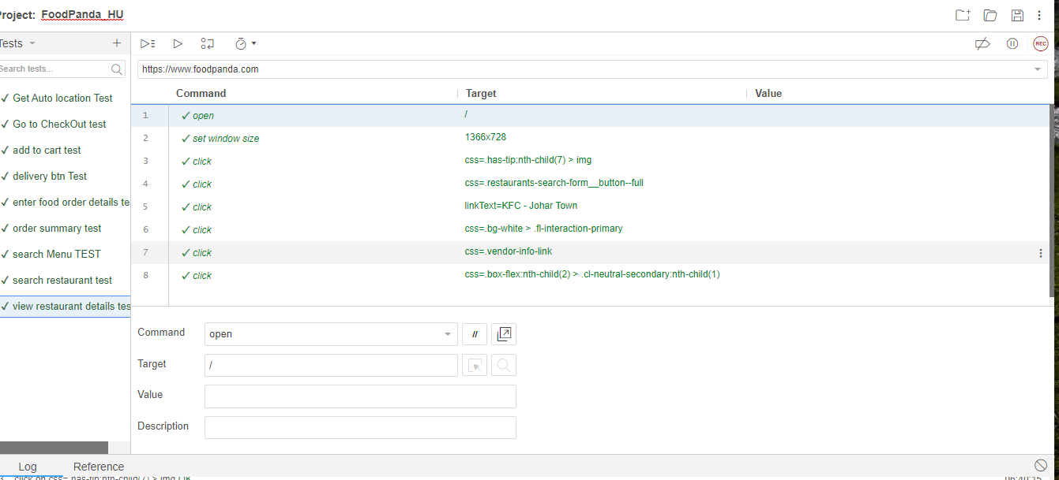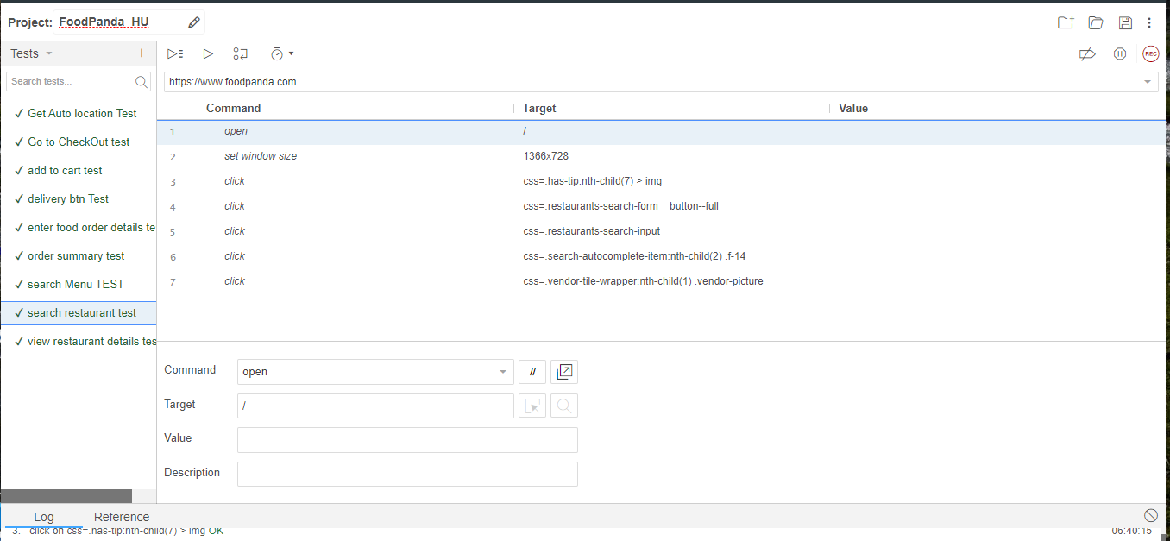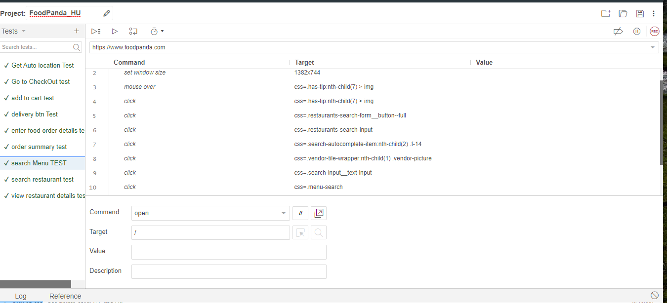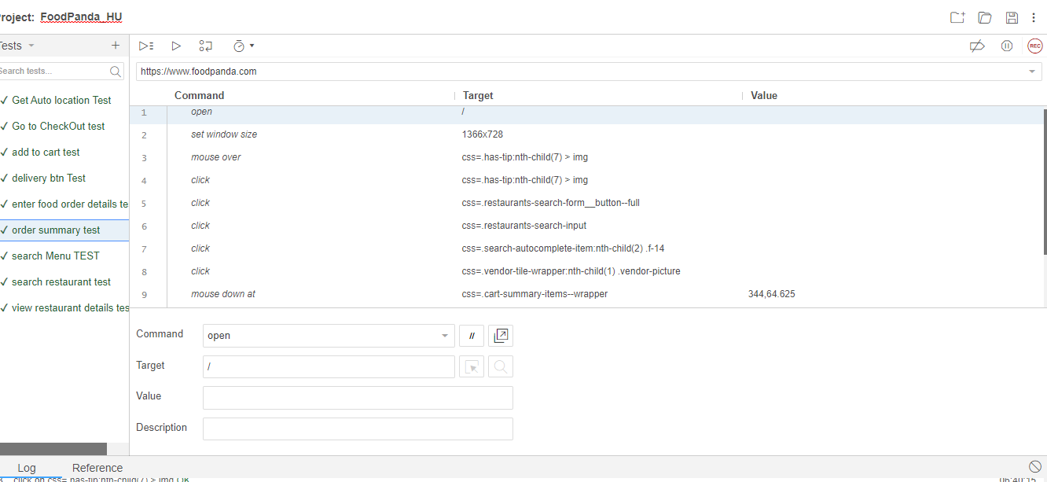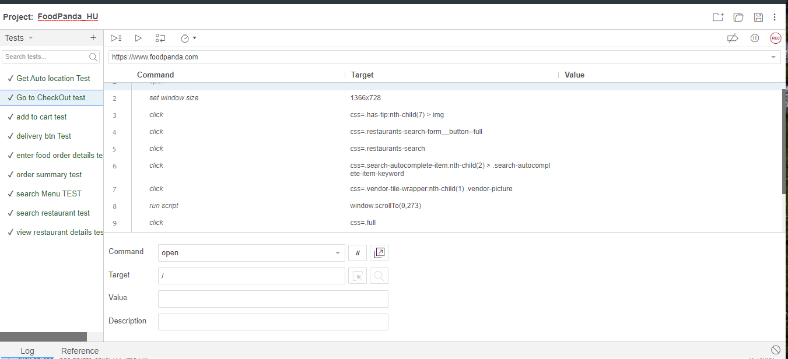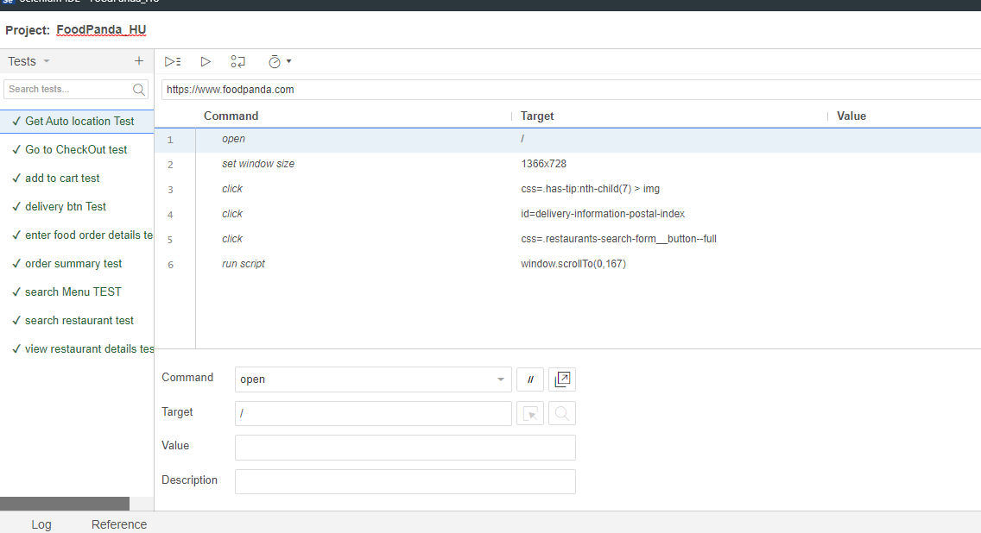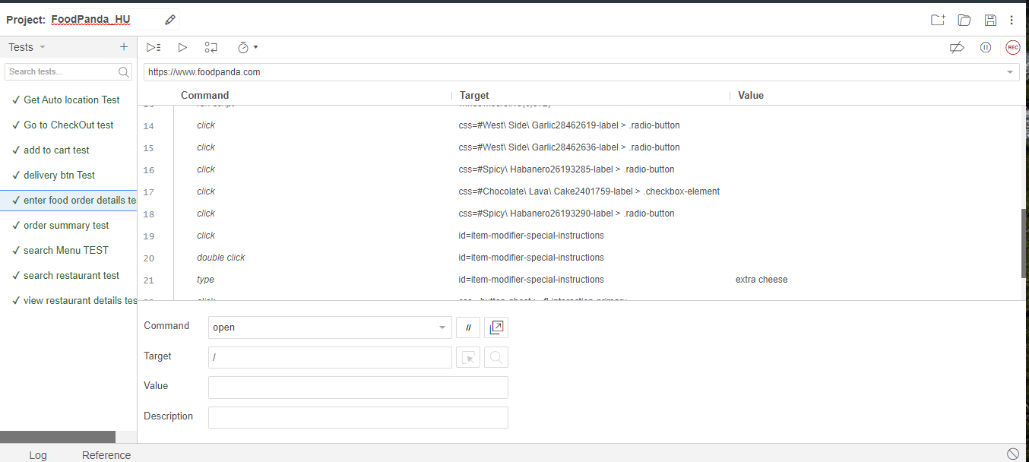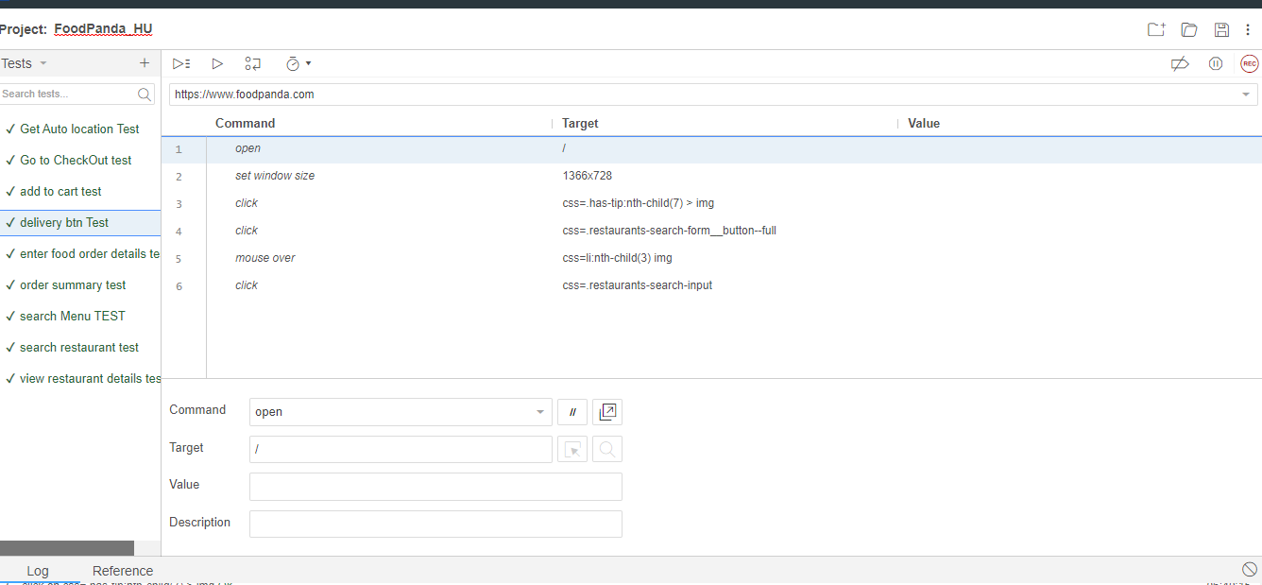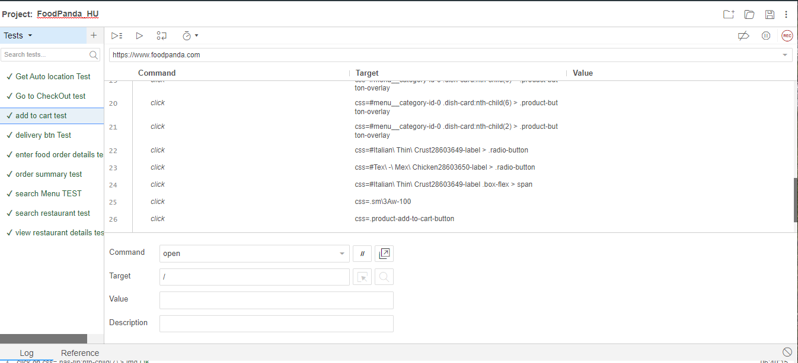**

**Food Panda Test Suite:  
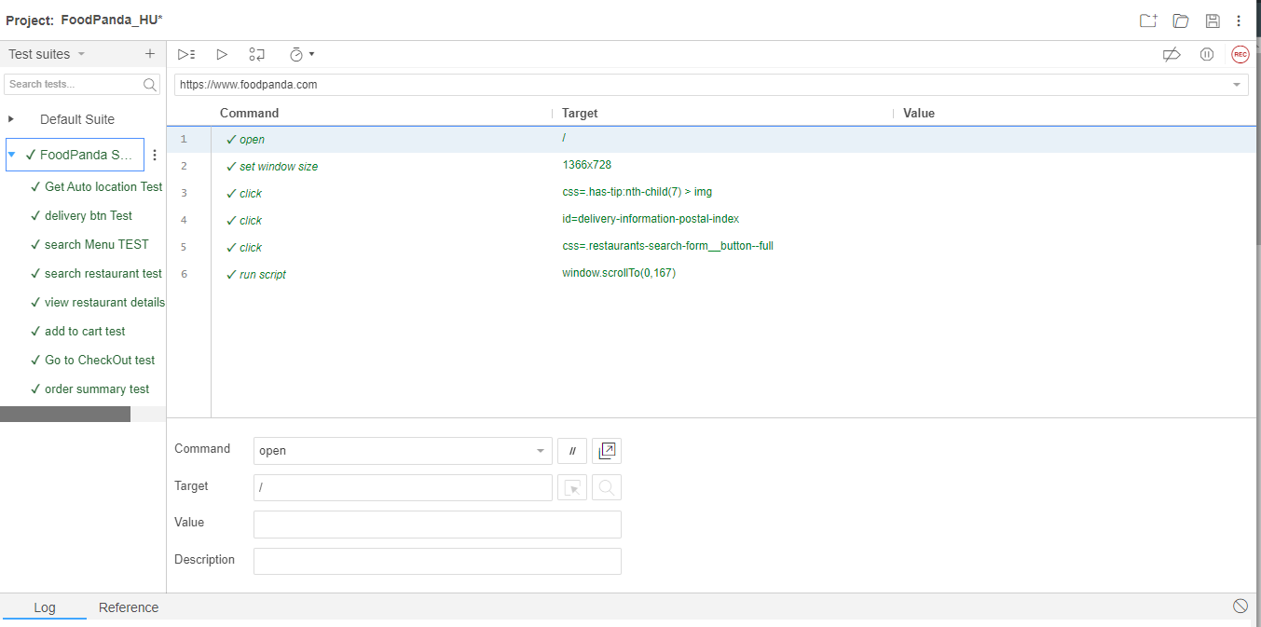**

**How script based testing is compared with the record and replay style of testing?**

On the basis of expertise technically there are primary difference based on the planning, test strategy, execution etc.

**Record and replay testing:**

* Basically record and replay testing is used for black box testing and it is suitable where the website is static.
* It is used where the user interface is static and there less changes.
* In record and replay testing if the scripts of test cases are large then they may have impact on execution speed.
* This can be used by even who are not inside of development team.
* There are also some problems with it as it has too much recording or sometimes too less recording.
* Test scripts might be difficult to understand I it is in loop.

**Script based testing:**

* **Script based testing is** providing the automation of testing which automates the test of GUI.
* **Script** base testing is useful where the application is large and complex like having business rules, proper planning and executions etc.
* **Script base**d testing is important where we have repeatability.
* **As there** are also some problems with this testing as it is time taking testing so it is not suitable for rapid processes.
* **If requirements are not clear** it would be difficult to make test cases and run them.

**Why your test suite is of best quality?  
My** test suite is of best quality as it provides the fast execution in running all the tests. And also It gives the automation correction signs if there is any bug occur. My test suite is providing the synchronization among all the tests which are running in the proper way.

* I am facing some issues regarding my execution and development time by using the scout I found it tough to understand and faced problem in execution time measurement.